Quantifying synchrony and variability in source water quality across nested catchments of a protected second growth forested water supply area

Hannah J. McSorley

Feb. 17, 2020

DRAFT 2

# Abstract (max 350 words) - roman numeral TOC

…in progress…

This research contributes to understanding the “natural” variability in DOM and DOC across a forested riverine watershed: the Leech River watershed on Vancouver Island, British Columbia, Canada. Land-use impacts are minimal in this research area as 96% of the watershed is protected as drinking water supply area (Leech Water Supply Area). Like most forested areas on Vancouver Island, the Leech watershed is second-growth softwood forest with a history of extensive harvest (nearly 96% cleared).

The purpose of this master’s research project was to establish a baseline understanding of hydrologic responses and water quality variability in rivers across the LWSA. The approach includes advanced synoptic sampling within stormflow, supplemented with standard grab samples between storm events and during summer baseflow. Discrete samples of river water were collected passively during the rising limb of stormflow (falling limb prototype in progress) using low-powered, low-cost, custom-built vertical rack samplers including water level loggers (Odyssey) and observational reference staff gauges. By collecting samples during stormflow, a more robust understanding of water quality dynamics was achieved than basic grab sampling alone. Using low-powered passive sampling techniques allowed for multiple (six) sites to be equipped with monitoring/sampling racks, providing fairly good spatial resolution of hydrochemical variability across the watershed.

# Lay Summary (max 150 words) - roman numeral TOC

include plain-language summary

# Preface - roman numeral TOC

see: <https://www.grad.ubc.ca/sites/default/files/doc/page/thesis_sample_prefaces.pdf>

*TOC follows, then LOT, LOF, List of Illustrations, list of abbreviations

# Acknowledgments

This research work would not have been possible without the support and accommodation of the Capital Regional District (CRD) Watershed Protection and Management Division, Integrated Water Services (IWS) (Victoria, BC). I would like to acknowledge the help, support and assistance provided by the following CRD people: Tobi Gardner, Annette Constabel, Kathy Haesevoats, Joel Ussery, Ryan Biggs, Patrick McCoubrey, Burn Hemus, Christoph Moch, Jessica Dupuis, and Devon Barnes.

I’m grateful to have been supported by the entire CRD Field Operations Staff, thanks for making me feel welcome and included on site.

This research also would not have been possible without the support and encouragement from academic supervisors and partners from the NSERC forWater Network for Forested Drinking Water Source Protection Technologies: Bill Floyd, Mark Johnson, Suzanne Tank, Mike Stone, Dana Harriman, Monica Emelko, Uldis Silins, Axel Anderson.

For help with field installations and streamflow gauging, a big thanks to my former field partner, Stewart Butler, of Bill Floyd’s Coastal Hydrology Research Lab; thanks Stew. Thanks also to Alison Bishop for field assistance during the winter of 2019/2020.

Last but certainly not least, thanks to my wonderful friends and family for supporting me in my scientific and academic pursuits. I really appreciate all the love and support, bike rides and beers, proof-reading and encouragement.

# Dedication

To each person who reads this thesis in its entirety.

For the love of data science, I am grateful for Jenny Byran’s online resources, StackOverflow (<http://stackoverflow.com>) for the solution to so many coding challenges. Thank you to RStudio for making a functional and friendly IDE for the R programming language and to GitHub for making version control streamlined and reproducible. Cheers to Hadley Wickham for the tidyverse and Yihui Xie for the bookdown package (in which I generated this thesis).

Table of Contents

Abstract (max 350 words) - roman numeral TOC 4

Lay Summary (max 150 words) - roman numeral TOC 5

Preface - roman numeral TOC 6

Acknowledgments 7

Dedication 8

1 Introduction 9

1.1 Forested source water supplies and drinking water treatment 9

1.2 Aqueous natural organic matter 10

1.3 Watershed processes and water quality 11

1.4 forWater & CRD GVWSA 13

1.4.1 The forWater NSERC Strategic Network for forested drinking water source protection technologies 13

1.3.2 Greater Victoria Water Supply Areas 14

1.5 Research Objectives 15

2 Methods 16

2.1 Study Site: Leech River Watershed 16

2.1.1 Climate, Weather, Forests 17

2.1.2 Synoptic sampling sites 19

2.1.3 Subbasin monitoring sites 19

2.1.4 forWater Coordinated Treatability Analyses Sites 23

2.2 Analytical techniques & data 24

2.2.1 Quantifying dissolved organic carbon (DOC, as NPOC) 24

2.2.2 Qualifying organic matter through spectrophotometry 25

2.2.3 Sampling for Metals & CRD Analytical Results 27

Data & Results (visualization & summaries) 28

Sample Counts and data table summaries 28

Leech DOC concentrations 28

DOC and metals in solution 30

Sampling campaign 31

Seasonal examination of DOC & DOM dynamics 33

Spectral Indices 36

Plots of DOC & proxy 36

Discussion 38

Conclusions 39

References 40

Appendix A 45

A-1 Greater Victoria Regional Water Supply System 45

A-2 Leech River Watershed Site Details 46

A-2.1 Sub-basin Sites 47

A-3 Methods (extended) 53

A-3.1 Vertical racks: passive water sampling on the rising limb of hydrograph 53

A-4 Details: forWater NSERC Strategic Network for forested drinking water source protection technologies 55

# 1 Introduction

## 1.1 Forested source water supplies and drinking water treatment

Surface water is the primary source of drinking water for over 85% of the Canadian population and in the province of British Columbia, approximately 80% of drinking water originates from forested headwaters (Pike et al. 2010). Forests offer a variety of ecosystem services (e.g. biodiversity) and also slow and filter runoff, resulting in high quality source water supply (Dudley and Stolton 2003). Surface water quality varies over time and space due to climate, weather, and physical characteristics of the watershed (such as topography, land cover and geology), and runoff processes introduce terrestrial material, sediments, nutrients, and organic matter to surface water (Pike et al. 2010; Johnson et al. 1997; Delpla and Rodriguez 2016; Health Canada 2019; Yang et al. 2015).

In Canada, all drinking source water is treated to meet Health Canada drinking water quality guidelines, which specify allowable levels of biological, physical and chemical parameters that are safe for human use and consumption (British Columbia Ministry of Environment 2017). Drinking water treatment processes vary from simple chlorination to multiple stages of chemically assisted filtration in combination with advanced oxidative processes. Water treatment protocols differ between communities based on source water quality, infrastructure capabilities, budget, and regional water quality regulations [!!REFS]. Chlorination remains the most widely used method of inactivating potentially harmful microorganisms, whether it stands alone as the primary and sole treatment protocol, or is used in combination with other processes (HealthCanada 2006; HealthLinkBC 2018).

When natural source water is chlorinated, chemical reactions with natural organic matter (NOM) can form a variety of chlorinated organic compounds which are broadly classified as disinfection byproducts (DBPs) (Richardson et al. 2007; Delpla and Rodriguez 2016; Health Canada 2019; Yang et al. 2015; Hua, Reckhow, and Abusallout 2015; Eaton, A. D., Clesceri, L. S., Greenberg, A. E., Franson 2000). A number of DBPs are included in Health Canada’s drinking water quality guidelines, and have maximum allowable concentrations in treated water due to their potential or known health affects (i.e., genotoxicity and carcinogenicity) (Richardson et al. 2007; British Columbia Ministry of Environment 2017).

## 1.2 Aqueous natural organic matter

Source water treatability varies with Natural organic matter (NOM) concentration and character, which depend on source material, hydrology, and biogeochemical factors (Aiken, Hsu-Kim, and Ryan 2011; Abbott et al. 2018; Zarnetske et al. 2018). Molecular composition and physical structure influence NOM reactivity, therefore different types of aqueous NOM have different disinfection byproduct formation potentials (DBP-FPs) (Delpla and Rodriguez 2016; Yang et al. 2015; Health Canada 2019; Chow et al. 2008). NOM comprises a dynamic collection of molecules from a variety of sources, and aqueous NOM exists in complex and diverse combinations of particulate, colloidal and dissolved fractions. NOM can be introduced to a water body from terrestrial sources or generated through in-stream processes which are often associated with autotrophic organisms like algae and cyanobacteria (autochthonous NOM). Terrestrial organic matter (allochthonous NOM) includes humic and fluvic acids, tannins, and a wide variety of other compounds (e.g. phenols and lignin, hydrocarbons, proteins, carbohydrates, etc.), which enter fresh water through runoff processes (Zarnetske et al. 2018; Health Canada 2019).

NOM molecules contain nitrogen, silica, oxygen and hydrogen but are composed primarily of organic carbon; thus, organic carbon is often measured as a proxy for NOM concentration (Health Canada 2019). Total organic carbon (TOC) is operationally divided into particulate and dissolved fractions (POC and DOC, respectively) which are typically distinguished based on separation by a 0.45-micron filter (Eaton, A. D., Clesceri, L. S., Greenberg, A. E., Franson 2000; Aiken, Hsu-Kim, and Ryan 2011). Generally, DOC is the predominant fraction of aqueous TOC, and the amount of DBPs in treated water is proportional to raw water DOC concentration (Weishaar et al. 2003; Chow et al. 2008). As DOC is likely to generate DBPs during chlorination, it is an important source water quality parameter to monitor. In fact, guidelines in British Columbia specify that source water TOC should remain below 4 mg/L to reduce DBPs in treated drinking water (British Columbia Ministry of Environment 2017).

In addition to acting as a precursor for DBPs, NOM has the ability to bind and transport contaminants in solution (e.g. metals, organic pollutants, nutrients) and influences stream pH, as well as aquatic light and temperature regimes (Oni et al. 2013; Aiken, Hsu-Kim, and Ryan 2011; Weishaar et al. 2003; LaZerte 1991; Palleiro et al. 2013; Stanley et al. 2012). NOM is an energy source for aquatic heterotrophic microbes (Stanley et al. 2012) and as such, could contribute to biofouling of water supply and treatment infrastructure (which could lead to service disruptions). DOC has been called a “master variable” due to it’s terrestrial-aquatic linkages, influence on water chemistry and role in contaminant transport (Zarnetske et al. 2018). Within a watershed, the characteristics and concentrations of NOM (and therefore DOC) naturally fluctuate over space and through time, creating dynamic treatability conditions (Li et al. 2014, @Yang2015).

## 1.3 Watershed processes and water quality

Streams are intrinsically linked to their watersheds through dynamic biotic-abiotic interactions and hydroclimatic relationships; as a result, aqueous biogeochemicals represent an important link between ecosystem processes, hydrology, and water resources. Biogeochemical signatures are useful tracers to better understand catchment processes and regional hydrology, as they are indicative of flow paths, sources, chemical origins and transport pathways (Abbott et al. 2018; Meyer and Tate 1983; Vidon, Wagner, and Soyeux 2008; Rautu 2019). The origins, transport and fate of biogeochemicals in source waters is important for drinking water treatment, because the quality of source water (physiochemical composition and concentrations) governs treatment requirements and largely dictates the quality of treated water, particularly with respect to disinfection byproducts (Weishaar et al. 2003; Chow et al. 2008).

Water quality parameters exhibit natural variability across a river network due to dynamic biotic and abiotic interactions. For example, the river continuum concept (RCC) predicts a temporal shift in DOM character, including seasonal shifts between autotrophic generation of NOM and heterotrophic processing of detritus (i.e. autochthonous to allochthonous DOM) (Vannote et al. 1980; Meyer and Tate 1983). The RCC also predicts a spatial reduction in DOM molecular diversity from headwaters (entry point for majority of solutes) to river mouth (i.e., reduced DOM diversity from low to high order streams) (Vannote et al. 1980; Mosher et al. 2015; Abbott et al. 2018; Creed et al. 2015). The longitudinal attenuation of DOM diversity can be explained by a combination of hydrological processes; geomorphic variables and physical impoundments; organic matter inputs and sources; sediment transport; solar inputs; and processing by aquatic invertebrates and microbes (Vannote et al. 1980; Stanley et al. 2012; Aiken, Hsu-Kim, and Ryan 2011; Zarnetske et al. 2018).

On a finer temporal scale, hydrologic pulses can cause temporal variability in DOM characteristics; for example, the character of DOM has been shown to vary during hydrologic response to precipitation, which indicates a change in DOM source over the course of an event (Vidon, Wagner, and Soyeux 2008; Abbott et al. 2018). The Pulse Shunt Concept (PSC) supplements the temporal aspects of RCC by considering how major hydrologic events drive regional DOM metabolism and the magnitude, timing and spatial extent of DOM flux (Raymond et al. 2016). While the link between mobilization of source material and biogeochemical processes govern the character of aqueous NOM, the PSC shows that it is hydrologic processes that govern NOM concentrations in streams (Abbott et al. 2018; Creed et al. 2015; Zarnetske et al. 2018). Where the RCC relies on in-stream biogeochemical processing to explain longitudinal alteration of NOM character, intense hydrologic pulses (related to precipitation or melt events) override the rate of biogeochemical processing and force mass transport events. Discharge determines the magnitude of DOC flux (i.e., concentration transport) and under pluvial regime, precipitation and discharge are the primary controls on stream DOC concentrations (Zarnetske et al. 2018; Vidon, Wagner, and Soyeux 2008). Indeed, brief flood events are often responsible for the majority of fluvial DOC transport in a watershed (Raymond et al. 2010).

Through a large and geographically diverse data study in the United States, Zarnetske *et al* (2018) found that increasing flows systematically increased DOC fluxes in 80% of watersheds (n=1006) across ecoregions. Proportional increases in DOC flux and discharge indicates that the flux is not limited by organic matter supply, but rather by hydrologic connectivity and mobilization (Creed et al. 2015; Zarnetske et al. 2018). Watershed size and stream order were determined to be weak indicators of DOC flux-discharge relationship while watershed slope and mean precipitation were strong predictors of DOC flux (Zarnetske et al. 2018). Zarnetske *et al* (2018) also found that wetland area exerted non-linear control over whether DOC flux was limited by supply or hydrologic transport.

Aspects of both the RCC and PSC were illustrated in a recent nested catchment study by Abbott *et al* (2018) which found greater DOM chemical diversity in headwaters relative to downstream, but not greater temporal variance in headwaters biogeochemistry. Despite longitudinal differences in molecular character, solute concentrations varied synchronously among upstream and downstream sites, leading to temporal stability in relative biogeochemical signatures (Abbott et al. 2018). The temporal extent to which water quality changes echo across nested subcatchments depends on the synchrony (i.e. mean covariance) of the hydrologic pulse generation among subcatchments (Abbott et al. 2018).

## 1.4 forWater & CRD GVWSA

### 1.4.1 The forWater NSERC Strategic Network for forested drinking water source protection technologies

The NSERC Strategic Network, forWater, is a transdisciplinary cross-Canada applied research collaboration focused on the connections between treated drinking water quality and land-use impacts of forest management. The majority of source drinking water originates in forested headwaters, but the connection between upstream forest management and downstream treatment remains poorly understood. forWater researchers are studying water quality in watersheds across Canada, under a variety of different forest management strategies. Through collaborative analyses, forWater is working to evaluate source water treatability metrics, downstream propagation effects, and resource economic with the ultimate goal of providing a framework for treatement demands.

Forest management and landscape disturbances can ultimately effect water treatability by altering material inputs, biogeochemical processes and stream ecology, as well as changing preferential flow-paths and the mobilization, transport and dilution of biogeochemcial components (Meyer and Tate 1983). It has been shown that, two to three years post-harvest, baseflow DOC concentrations were higher in forested catchments than in clear-cut catchments; however, these studies also showed variable stormflow DOC responses in harvested and forested catchments (Meyer and Tate 1983; Mistick 2019). In the absence of long-term baseline data (i.e., pre- and post-disturbance data sets), the natural variability in fluvial processes complicates land-use studies and anthropogenic climate change can further confound our interpretations. Overall, DOC trends related to land-use seem highly dependent on catchment attributes and hydrologic forces. High intensity and/or long duration precipitation events can deplete both terrestrial and aquatic NOM storage sources (e.g. high flows can disturb benthic NOM storage) (Meyer and Tate 1983). Understanding the hydrochemistry of a water supply area is key to conducting informed preventative forest management applications.

### 1.3.2 Greater Victoria Water Supply Areas

The Capital Regional District, a forWater Partner, is committed to the multiple barrier approach to clean drinking water and has taken control of source water protection by purchasing and privatizing the water supply areas for Greater Victoria. Located on southeastern Vancouver Island, British Columbia, the Greater Victoria Water Supply Area (GVWSA) includes 20,549 hectares (205.49 km2) of protected drinking water catchment lands. Currently, Greater Victoria’s water supply is sourced from five surface water reservoirs in the Sooke and Goldstream watersheds. In 2007 and 2010, the CRD purchased and additional 96.28 km2 (9,628 hectares) of land which included the majority of the Leech River watershed (a major sub-catchment of the Sooke River watershed). In anticipation of future water demands, this area was designated as a supplemental water supply for Greater Victoria: the Leech Water Supply Area (LWSA). In the future (possibly by 2050), inter-basin transfer will supplement the primary drinking water supply by moving Leech River water through a diversion tunnel to Sooke Reservoir. Approximately 92% of the Leech River watershed above the point of diversion (Leech Tunnel) is protected as WSA.

Overall, the hydrology of the LWSA is poorly understood, as are water quality dynamics. In the mid-1980’s, some water was transfered from the Leech River into Deception Gulch and Reservoir (adjacent to but physically separated from Sooke Reservoir). The mixing resulted in biological water quality problems that included odour and raised concerns about the operational usage of the existing tunnel. The Leech River Tunnel and anticipated inter-basin transfer will provide many interesting research opportunities. Before work is done on inter-basin transfers, the hydrology and water quality of the Leech River system need to be better understood. Understanding source water quality, as well as the timing and magnitude of flows, is an essential component to multiple barrier approach to ensuring clean drinking water.

#### 1.3.2.1 Forest management

The LWSA was privately managed forest land which was extensively harvested over the past 70 years (nearly 96% clearcut); as a result, a large portion of the WSA is densely forested with softwood stands less than 35 years of age. The second growth forests of the LWSA are no longer managed for timber supply, they are now managed to improve drinking source water quality and to reduce the risk of landscape level wildfire. Due to harvest, reforestation and active fire suppression, forest fire fuels have accumulated and pose a threat in the event that a fire occurs. In the Sooke WSA, the CRD implements forest treatments designed to foster healthy forest stands capable of reducing fire intensity, such as reducing fuel hazards and creating conditions that are safe for crews to action a fire. Similarly, preventative fire treatments may be applied in the LWSA prior to inter-basin transfers. Developing an understanding of baseline water quality dynamics and hydrologic forces in the LWSA will help to inform forest management strategies by evaluating the effects of fire fuel management on water supply.

#### 1.3.2.2 Greater Victoria Drinking Water Treatment

Island Health is the Vancouver Island Health Authority which oversees drinking water systems regulated under the provincial Drinking Water Protection Act and Drinking Water Protection Regulation frameworks. In keeping with Health Canada’s drinking water quality guidelines, the Act sets out requirements for drinking water operators & suppliers to ensure the provision of safe drinking water. The CRD complies with all drinking water requirements as well as several that are not enforced in the province of BC. Treatment of source water from the Greater Victoria Water Supply Area is fairly simple: raw water (unfiltered) is treated with ultraviolet light as primary disinfection, chlorination is secondary, and finally ammonia is added to produce chloramine (NH2Cl, a long-lasting disinfectant that persists throughout distribution). Understanding dynamics and variability of hydrochemistry in the LWSA is needed to anticipate possible treatment challenges that may accompany future inter-basin transfer from the LWSA.

## 1.5 Research Objectives

As a member of the Watershed Science and Forest Management Theme of forWater, this research was conducted in partnership with the CRD to contribute to their pursuit of characterizing the Leech Water Supply Area, while contributing to our understanding of “natural” variations in source water quality (primarily with respect to DOM and DOC) across nested catchments in a second growth forested watershed. The objectives of this research were to quantify spatial and temporal patterns in DOC concentrations, and to explore the hydrochemical synchrony of nested catchments across the LWSA. Ideally, results of this research will contribute to baseline understanding for further exploration of forest management strategies, such as fire fuel management, and their impacts on source water quality and supply. Understanding source water quality, as well as the timing and magnitude of flows, is an essential component to multiple barrier approach to ensuring clean drinking water.

# 2 Methods

## 2.1 Study Site: Leech River Watershed

The Leech River watershed is a sub-catchment of the Sooke River watershed, located west of Sooke Reservoir (primary water supply for the Greater Victoria Area). In anticipation of future water demands and uncertainty related to rainfall and climate change, the Capital Regional District (CRD) purchased about 92% of the Leech River watershed in 2007 (84%) and 2010 (additional 8%) and designated the Leech Water Supply Area (LWSA) for future supplemental source water. Figure ### shows the Leech and Sooke Water Supply areas with elevation. 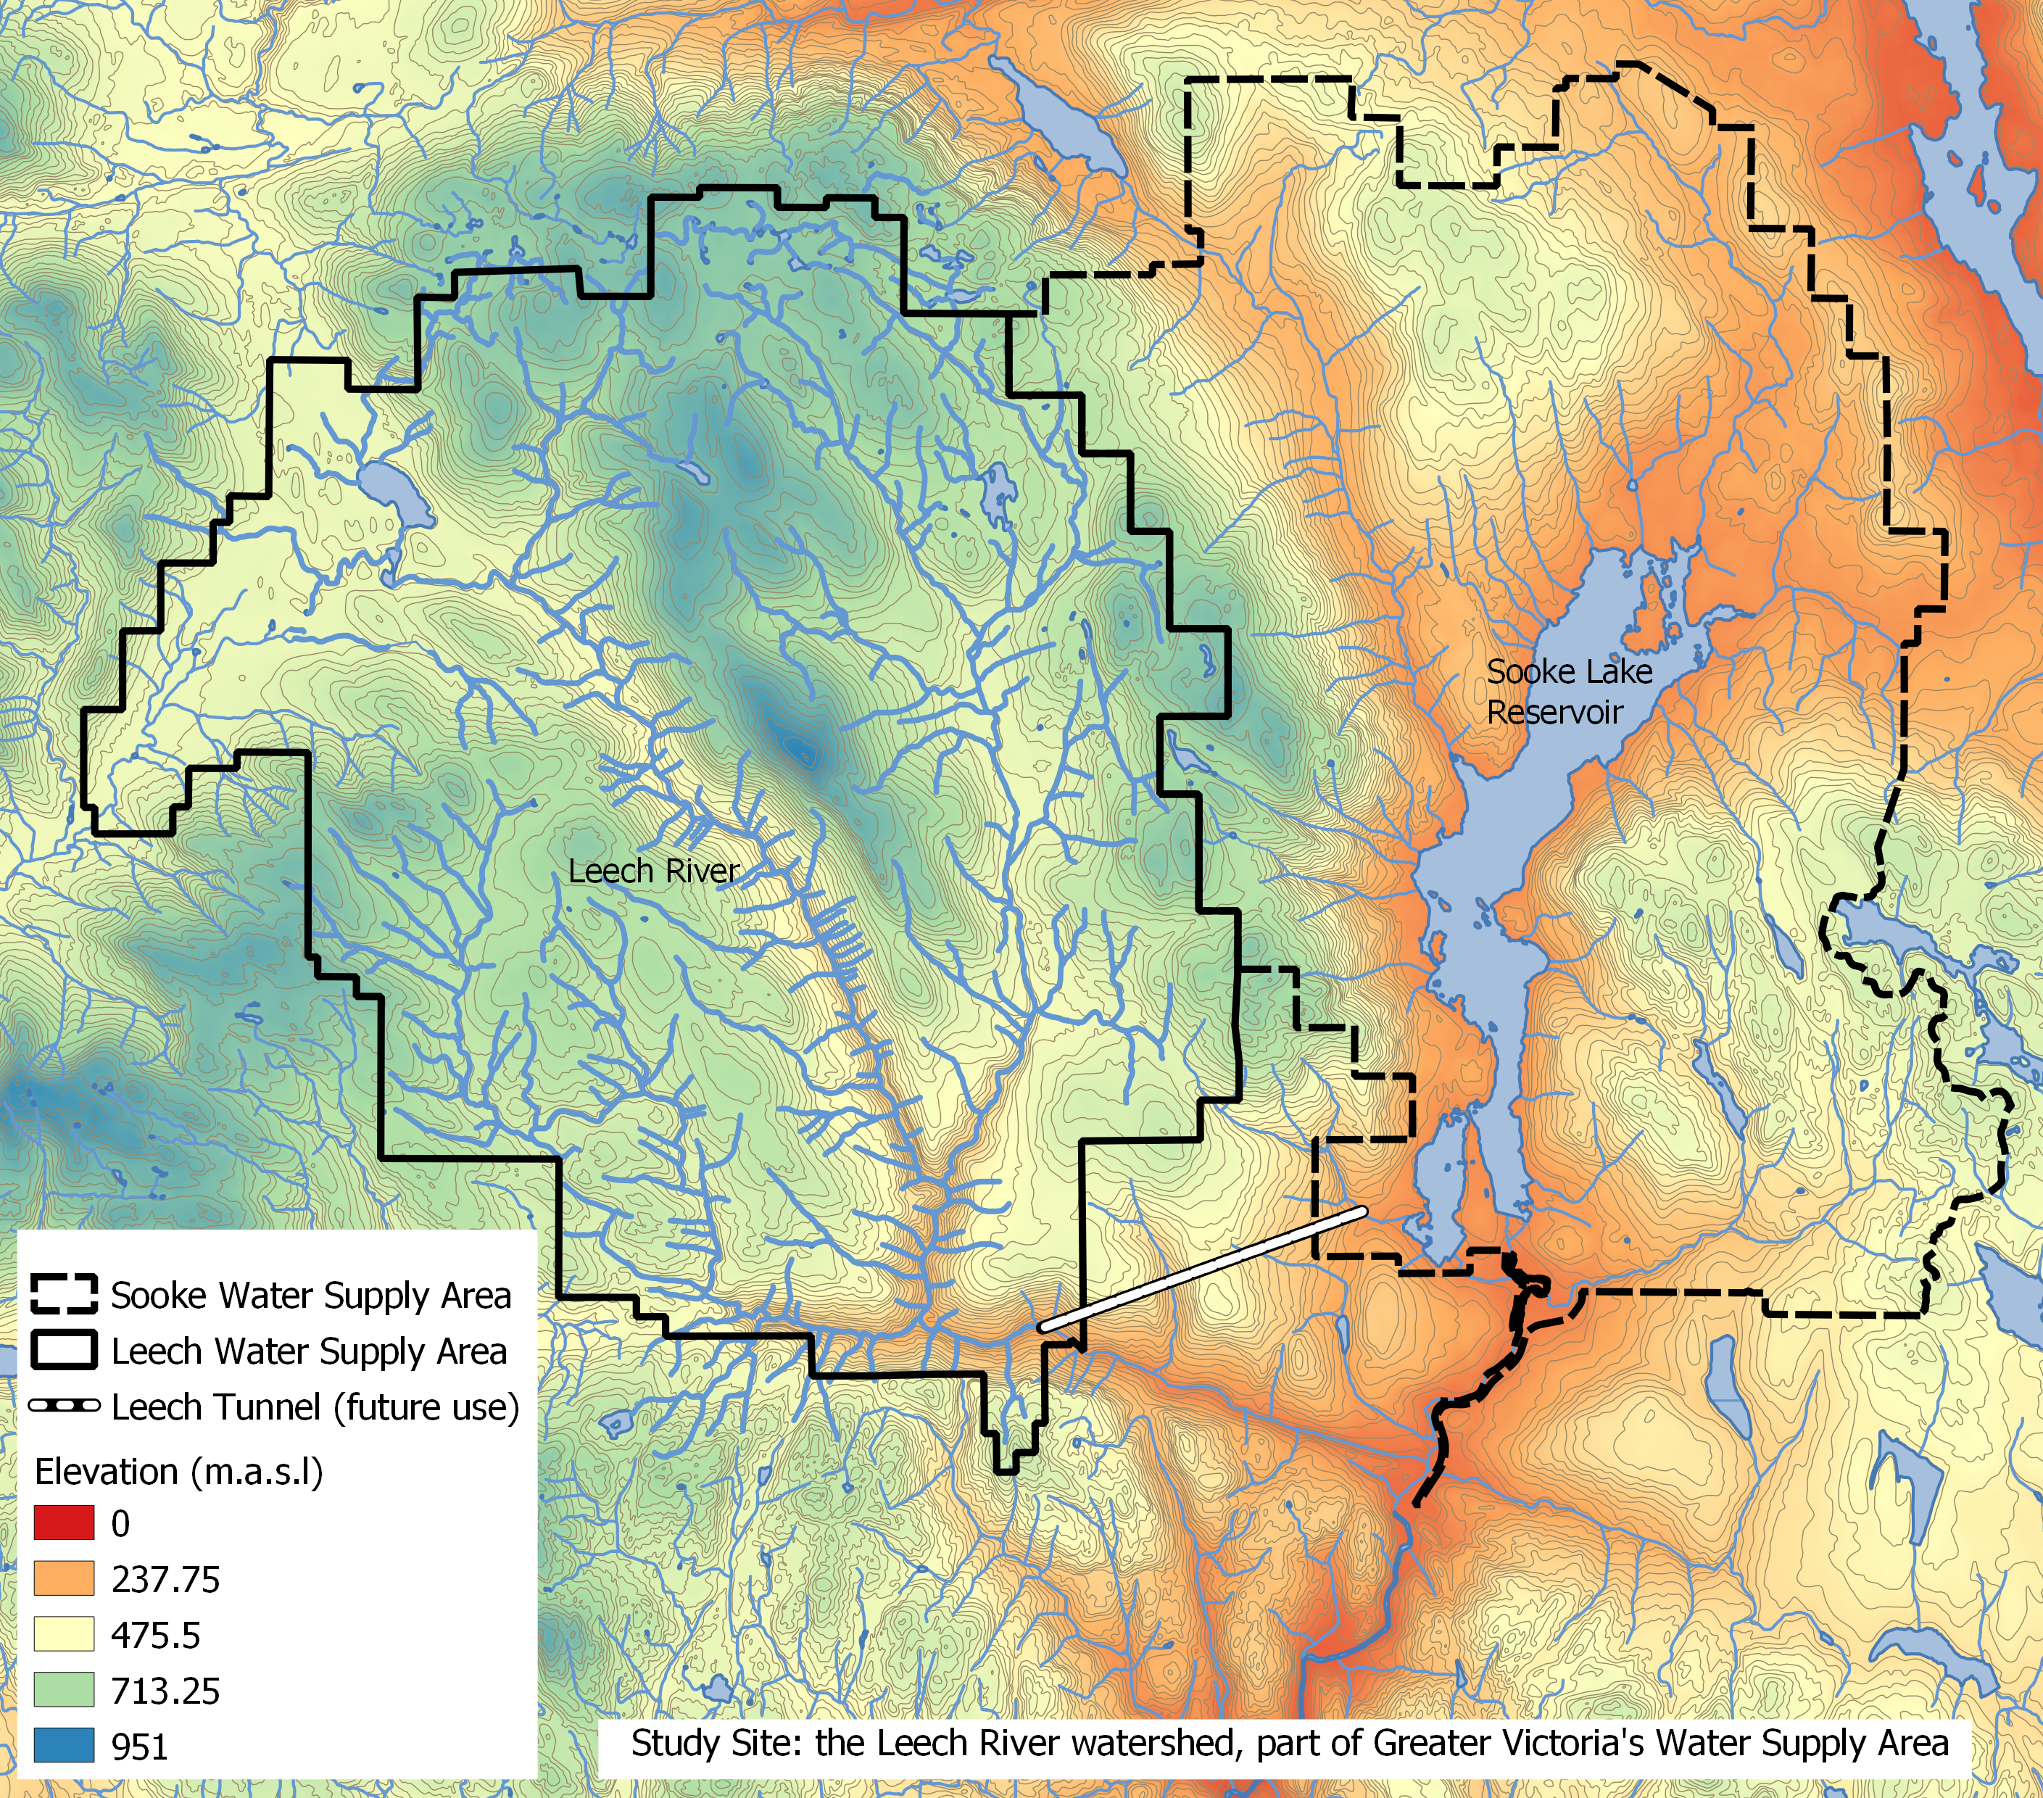

While monitoring programs began in 2017, the hydrology and water quality in the LWSA are poorly understood. The Leech River watershed includes three mainstem rivers (Cragg Creek, Leech River, and West Leech River) as well as several small headwater lakes (Weeks, Jarvis, and Worley) and wetlands (Jordan Meadows surrounding Weeks Lake and Lazar meadows north of Jarvis Lake). Runoff peaks in the winter under saturated conditions when rivers respond rapidly to precipitation events, rising and falling dramatically. Across the watershed, elevation ranges from approximately 200 m above sea level (asl), near the Leech Tunnel, to 941 m asl in the centre of the watershed, at the top of Survey Mountain.

### 2.1.1 Climate, Weather, Forests

The Leech River watershed is in the Coastal Western Hemlock biogeoclimatic zone (CWH), with forests dominated by Douglas-fir (Pseudotsuga menziesii), western hemlock (Tsuga heterophylla) and western red cedar (Thuja plicata); subspecies include white pine (Pinus monticola), amabalis fir (Abies amabilis), alder (Alnus rubra), broad-leaf maple (Acer macrophyllum) and arbutus (Arbutus menziesii). The watershed also includes the moist and dry maritime sub-zones of the CWH (Montane moist 43%, submontane moist 38%, xeric 19%) (Ussery and AECOM 2015). While some precipitation occurs as snow at higher elevations, the majority of the ~2500 mm per year is rain (i.e., pluvial hydroclimatic regime). The water year can be broadly divided into wet and dry seasons where approximately 90% of precipitation falls from October to April, and May through September are relatively dry.

There are two weather stations which operated during the study period: Chris Creek station is located in the headwaters of the LWSA and Martin’s Gulch station is located near the future diversion point (Tunnel). The CRD provided weather station data from Chris Creek and Martin’s Gulch weather stations from 2018-01-01 to 2020-01-30. Rainfall and air temperature from each of the two LWSA weather stations is shown in Figure ??.

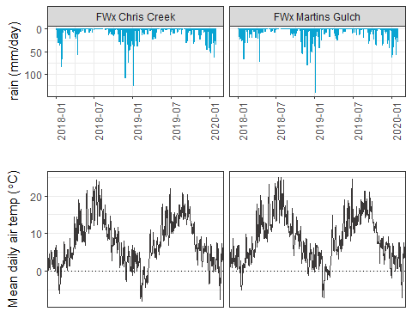

Slightly more precipitation was recorded at Martin’s Gulch than Chris Creek station. Between the two sites, average annual rainfalls were 2010 mm in 2018, and 1460 mm in 2019. In January 2020, the LWSA weather stations recorded 512 mm of rain (including periods of rain on snow).

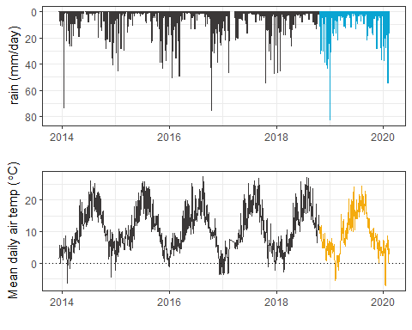There is a weather station on the Malahat mountain pass, east of the study site (ID 62091, BC Ministry of Transportation and Infrastructure and Pacific Climate Impacts) that had precipitation and air temperature data available from 2014 to 2020. Figure ?? shows weather data from the Malahat weather station and highlights the period in which this research occurred in which there were no obvious deviations from previous years.

### 2.1.2 Synoptic sampling sites

Fifteen sites were sampled synoptically from October 2018 to February 2020. Figure ### shows the locations of the synoptically sampled sites as well as the two weather stations. 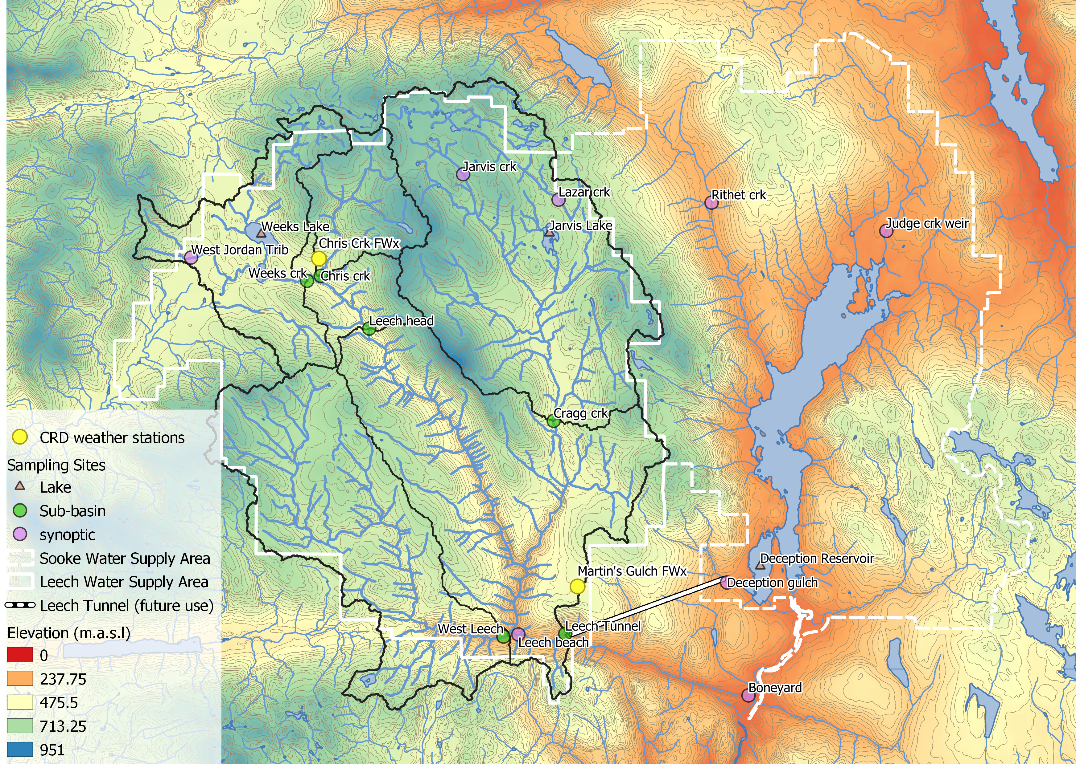

Synoptic sampling involved collecting grab samples in triple-rinsed acid-washed 250 mL amber HDPE bottles. Samples were capped with minimal headspace and transported on ice. Synoptic samples were collected bi-weekly to monthly. Results from synoptic sampling help to inform spatiotemporal patterns in water quality.

### 2.1.3 Subbasin monitoring sites

Six sites were selected across the Leech Water Supply Area which represent five nested catchments and the entire water supply area basin defined from the point of (future) diversion, the Leech Tunnel. These subbasin research sites represent important portions of the Leech River system: two headwater streams (Weeks and Chris Creek), the head of Leech River (below the confluence of the two headwaters), two mainstem rivers that feed the Leech (Cragg Creek and West Leech) and the Leech River at the Tunnel).

|  |  |  |  |  |  |  |  |  |  |
| --- | --- | --- | --- | --- | --- | --- | --- | --- | --- |
| Site Number | Site Name | Latitude | Longitude | Characteristic | Drainage Area (km2) | Elevation (m a.s.l) | Percent Forest | Percent Wetland | Parent Material |
| 1 | Weeks | 48.57568 | -123.846 | Wetland-draining headwaters | 16.1 | 521 |  |  |  |
| 2 | Chris Creek | 48.57739 | -123.84 | Headwaters | 9.6 | 522 |  |  |  |
| 3 | Leech Head | 48.56647 | -123.826 | Mainstem river head | 26.2 | 476 |  |  |  |
| 4 | Cragg Creek | 48.54783 | -123.771 | Mainstem river | 37.1 | 509 |  |  |  |
| 5 | West Leech | 48.50688 | -123.785 | Mainstem river | 35.2 | 248 |  |  |  |
| 6 | Leech Tunnel | 48.50701 | -123.767 | Future diversion point | 98.7 | 207 |  |  |  |

#### 2.1.3.1 Subbasin sampling and installations

At each of the six subbasin research sites, a vertical sampling rack was installed. These racks collect discrete water samples during the rising limb of stormflow without employing costly pump-samplers, while recording continuous stage measurements (at ten minute intervals). Vertical sampling racks supplemented the synoptic sampling program by providing synchronized spatial resolution that would otherwise be difficult to achieve (i.e., multiple sites across the watershed), while collecting samples during flows that would otherwise be difficult or unsafe to access. Simultaneous stormflow sample collection can provide insights about relative hydrologic pulse responses across nested catchments (Abbott et al. 2018).

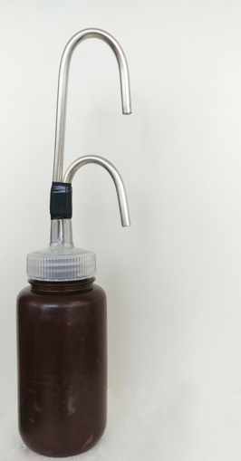The passive sampling bottles employ principles of a siphon design to collect river water as it reaches pre-determined levels on a vertical sampling rack. Siphon sampler bottles were based on a USGS single stage sediment sampler design (US U-59, 1961) which passively collect discrete water samples at a fixed stage on the rising limb of the hydrograph (Graczyk et al. 2000). The siphon samplers built for this research were 250 mL amber HDPE widemouth bottles with augmented screw caps. The caps were fit with two 1/4" (OD) stainless steel tubes, one longer than the other, both with a 180 $​^{∘}$ bend at the top end.

Each rack included a central stilling well (3.81cm (1.5“) PCV pipe with 1.27 cm (1/2”) holes along the length) with a measuring tape affixed to the front. Inside the stilling well was an [Odyssey Capacitance water level logger](http://odysseydatarecording.com/index.php?route=product/product&product_id=50); and on either side of the central stilling well was a slotted offset angle bar onto which hose clamps held sample bottles fit with custom siphon lids. By combining the height at which each siphon bottle filled with observed stage from the stilling-well tape and Logger data, the date and time for each rising-stage sample collection was determined.

These vertical racks collected whole water samples on the rising limb of the hydrograph. The rising limb has been shown to have higher DOC concentration than low flows between storm pulses (Yang et al. 2015; Raymond et al. 2016, 2010; Zarnetske et al. 2018). Increasing DOC on the rising limb indicates that source material is not limited and flux is driven by hydrologic connectivity; whereas source limited conditions likely drive DOM dynamics if DOC concentration decreases on the rising limb (Zarnetske et al. 2018). Analysis of rack samples clarifies the magnitude and direction of water quality changes in response to precipitation relative, which provides information about solute supply and hydrologic connectivity (Vidon, Wagner, and Soyeux 2008; Abbott et al. 2018; Creed et al. 2015; Zarnetske et al. 2018).

###### 2.1.3.1.1 Vertical rack sampling QA/QC: Siphon sampler assumptions

Rising level siphon samplers collect water from approximately 5cm below the surface (top of intake tube to inlet orifice). Data related to rack samples relies on two key assumptions: the water column is well mixed (no stratification) therefore the sample is representative of water quality at each sampling stage; and the sample is discrete such that there is no infiltration or mixing after the sample is collected. Based on the velocity and turbulence associated with flows in the step-pool formation of the subbasins, the assumption of unstratified waters seems very reasonable. The assumption of sample discretion was validated in lab using food colouring and a flow-through bucket system {tap water sample collected by siphon sample bottle, food colouring added to flow system after sample collection and circulated for ~15 minutes, sample bottle removed from dye chamber and sample colour compared to surrounding dyed water: no dye present in sample).

###### 2.1.3.1.2 Vertical rack sampling QA/QC: Sample hold-times and temperatures

Every effort was made to retrieve rack samples as quickly as possible from the racks, none the less they sometimes remained on the racks for several days (up to a week). Hobo TidbiT temperature sensors were deployed at each subbasin vertical rack to monitor air and water temperature in order to assess sample stability between sample collection and retrieval.

To assess sample stability hold-time experiments were performed. The hold-time experiments included replicate (n = 10) sample collection at a site, where half the samples were placed out of water on the vertical rack with siphon lids and the other half were returned to the lab for immediate analysis. Four hold-time experiments were completed such that the rack samples were left in the field for one, two, three, and four weeks before being retrieved and analyzed for comparison to their counterpart replicates.

###### 2.1.3.1.3 Prototype for falling limb passive sampling

In keeping with goals of low-cost, low-powered passive sampling, a falling-limb sampler was designed based on principles of the rising limb siphon sampler. The rising limb sampler collects a discrete water sample when river stage exceeds the crown of the inlet tube, so long as the vent is unobstructed; obstruction of the siphon sampler vent was the key component of the falling limb sampler prototype design. There were a half-dozen iterations in design prior to the model which was field-deployed in the Leech WSA (winter 2019). Each design iteration included a valve on the siphon vent which remained closed as the river rose, and opened when stream stage dropped below a certain point (allowing air to exit the sample bottle and a water sample to be collected). A number of valve options were explored, including: an external tube plug, in internal tube plug, and a self-sealing silicone bite-valve (i.e. Camelback Big BiteTM for hydration packs). The final design iteration used a tube pinch valve (SP Science) to close and open the air vent. The mechanism that triggers the vent valve to open is a simple fixed pulley, where the valve is connected to a weighted-cup by a wire that passes through two loops which alter the direction of force. The river rises and fills the cup with stream water, the cup remains full when the river recedes, and when the stream drops low enough that the full cup is no longer buoyant, the weight of water in the cup exerts a force on the lever of the pinch-valve, causing it to release the vent tube and triggering sample collection. The vent valve and trigger mechanism are contained in a 4" sewer pipe (a “filling well”), which was attached to supplemental support bars on the vertical rack. One prototype was field deployed at Cragg Creek (subbasin site 4) as a proof of concept and work will continue to improve the design and operation.

### 2.1.4 forWater Coordinated Treatability Analyses Sites

Four of the synoptic sampling sites were selected to collect source water treatability data in collaboration with researchers in the forWater Network. The sites were:

1. the Leech River at the future point of diversion,   
2. Deception Reservoir  
3. Rithet Creek (2nd largest tributary to Sooke Reservoir)   
4. Judge Creek (largest tributary to Sooke Reservoir)

These sites were selected to represent the future supplemental source water, the terminus or future balancing reservoir between Leech and Sooke water supply areas, and the current tributary source waters in the Sooke WSA (respectively).

Replicate samples were collected November 12, 2019 and January 18, 2020 and were shipped to the Universities of Alberta and Waterloo for treatability analyses. At the University of Waterloo, samples were analyzed for treatability parameters including: maximum potential disinfection byproduct formation potential (for trihalomethanes and haloacetic acids, (μg/L)), pH, UV254(cm-1), DOC (mg/L), Turbidity (NTU), Zeta Potential (mV), THM-FP(μg/L), HAA-FP (μg/L). At the University of Alberta, field-filtered samples were analyzed using a spectrofluorometer (for excitation emission matrices spectra), as well as an fourier transform ion cyclotron resonance mass spectrometer to determine molecular characteristics of the DOM.

## 2.2 Analytical techniques & data

Water samples were collected and transported via coolers (on ice) to UBC’s EcoHydrology Lab for analysis of dissolved organic carbon (DOC) concentrations and indicators of NOM character. Samples were also measured for phosphate concentration using a colourmetric (ascorbic acid) orthophosphate test kit (HACH PO-19); each sample had phosphate concentrations below detectable limits (0.1 mg/L). All data were analyzed with R (3.6.2) using RStudio IDE (Version 1.3.820).

### 2.2.1 Quantifying dissolved organic carbon (DOC, as NPOC)

For quantification of DOC, samples were analyzed for non-purgeable organic carbon (NPOC) via High-Temperature Combustion (Method 5310-B) on a Shimadzu TOC-V (Eaton, A. D., Clesceri, L. S., Greenberg, A. E., Franson 2000). For this method, samples were filtered with 0.45-micron PES filters, acidified to bring pH below 2, then sparged with hydrocarbon-free air to drive off inorganic carbon. Following sparging, samples were combusted to convert all organic carbon to carbon dioxide which was measured by non-dispersive infrared gas detector to quantify the DOC content of the sample. This method represents a direct measure of DOC; although small volatile organic compounds would be removed in the sparging process, most NOM compounds are of higher molecular weight and it is unlikely that NOM analytes would be lost (Eaton, A. D., Clesceri, L. S., Greenberg, A. E., Franson 2000; Matilainen et al. 2011).

### 2.2.2 Qualifying organic matter through spectrophotometry

#### 2.2.2.1 Proxy DOC

Spectral properties of sample NOM were analyzed using a ‘spectro::lyser’ spectrophotometer (s::can, Vienna, Austria) which measures turbidity and the chromophoric portion of organic matter to estimate concentrations of total organic carbon (TOC), dissolved organic carbon (DOC), as well as nitrate-nitrogen (NO3--N). For NOM to be detected by UV-Vis absorption, the molecules must absorb ultraviolet (UV) or visible (Vis) light, which relies on the electronic structure of the molecules. UV-Vis absorption requires the presence of conjugated pi-bond systems (i.e., chromophore) in the molecule, which are common in aromatic systems. Therefore, DOC quantified by the spectro::lyser is a proxy measure that represents the chromophoric component of DOM (CDOM), which is proportional to the samples’ average aromaticity. The suite of molecules that comprise NOM generally have an aromatic character (Weishaar et al. 2003). Increasing aromaticity will lead to greater absorbance at longer wavelengths, therefore an absorbance spectrum can provide information about a samples molecular character. For example, absorption of near-UV wavelengths (i.e., 200-380 nm) is indicative of conjugated systems that are common to aromatic compounds; as such, specific UV absorbance at 254nm (SUVA254) has been adopted as a surrogate for DOM aromaticity and, to some extent, its reactivity (Weishaar et al. 2003; Chow et al. 2008). The spectro::lyser measures absorbance from 200 nm to 750 nm wavelengths, across which several spectral indicies can be calculated.

#### 2.2.2.1.1 Quality control note

The spectro::lyser has been shown to effectively determine DOC content and character on unfiltered samples (Avagyan, Runkle, and Kutzbach 2014). However, suspended matter may bias absorbance values due to non-DOC light absorption or scattering. Therefore, spectral indices were not calculated for several unfiltered water samples that had detectable turbidity (greater than 0.000 FTU); this reduced the spectral dataset by 9.5%, from 347 to 314 spectral samples.

#### 2.2.2.2 SUVA254

Specific ultraviolet absorbance at 254nm (SUVA254) is the ratio of UV absorption (spectral absorbance coefficient, SAC, m-1) at 254nm wavelength, normalized to DOC concentration (mgL-1) (i.e., SAC254 divided by mgL-1-DOC) (Weishaar et al. 2003). SUVA254 correlates strongly with DOM aromaticity, and loosely with reactivity (Weishaar et al. 2003; Helms et al. 2008; Chow et al. 2008). A higher SUVA value indicates greater aromaticity, and a lower SUVA value indicates more alliphatic DOM. Because humic substances are more aromatic, SUVA254 is a good indicator of DOM from humic sources (i.e., allochthonous NOM) (Weishaar et al. 2003; Vidon, Wagner, and Soyeux 2008; Abbott et al. 2018).

With respect to SUVA254 and drinking water treatability, it’s important to consider the diversity of DOM and DBP species and the heterogeneous character contained in a water sample. While SUVA254 may indicate reactivity, it is not necessarily a strong indicator of DBP-FPs (Weishaar et al. 2003; Chow et al. 2008). This is because some DBP precursor NOM components (e.g., alliphatics), which have negligible absorptivities in the UV-Vis range, may contribute to DBPs but not SUVA254; additionally, not all NOM with measurable SUVA254 will create DBPs (Weishaar et al. 2003).

SUVA254 is reported in units of liter per milligram carbon per meter (Lmg-C-1m-1) and was determined by dividing the UV absorbance measured at wavelength 254 nm by the DOC concentration (from NPOC on the Shimadzu TOC-V).

#### 2.2.2.3 spectral indices of NOM character

Based on full scan data from the Spectrolyser (250-700nm), several indices of NOM character were determined. In the absence of fluorescence excitation-emission matrices, or high resolution spectrometric methods, spectral slopes are a simple tool for getting at molecule character. Spectral slopes (i.e., the change in absorbance intensity over a range of wavelengths) are semi-quantitative indicators for assessing DOM molecular weights (Helms et al. 2008). Spectral slopes over the wavelength range of 275-295 nm (S275-295, likely range for absorption by poly-aromatic hydrocarbons with 2 or more rings) and 350-400 nm (S350-400) were calculated from linear regression of loge-transformed spectra (spectral absorbance coefficients, m-1) as indicated by Helms (2008, p 958). Slope ratio (SR) is a unitless value equal to the slope of spectral intensity over the wavelength range of 275-295 nm relative to the slope of spectral intensity over 350-400 nm. SR is inversely proportional to CDOM molecular weight (Helms et al. 2008).  
The ratio of absorbances at wavelengths 250 nm and 365 nm provides a quotient called E2:E3 which is inversely related to aromaticity and molecular size of aquatic humic solutes (**???**; Helms et al. 2008). E2:E3 values were calculated, along with SR , to try to elucidate molecular character of DOM in samples.

### 2.2.3 Sampling for Metals & CRD Analytical Results

Aquatic NOM can play an important role in the transport of metals because it has the physiochemical ability to act as a ligand to create coordinated complexes with metals. From November 2018 to July 2019, I collected eight sets of samples for metals analysis from the six sub-basin monitoring sites. Metals samples were collected on behalf of the CRD and were analyzed at Bureau Veritas Laboratories in Sidney, BC (BL Labs, formerly Maxxam Analytics Inc.). For each metals sample collected, a parallel Grab sample was analyzed for DOC (at UBC). Reports from BL Labs were provided by the CRD for the samples collected in association with this research. Reports were pdf format which was exported to Excel and converted to .csv for analysis in R.

# Data & Results (visualization & summaries)

…. In progress…. (this is the same as the brief I sent previously)

## Sample Counts and data table summaries

In total 400 samples were collected (@ref(tab:sample summary table))

## Leech DOC concentrations overview

Table 1 and Figure 1 show DOC concentrations were highest at Weeks Creek, the headwaters monitoring point for a sub-basin which included Weeks Lake and surrounding wetlands. On average, Chris Creek DOC concentration was 51% lower than Weeks creek. Below the confluence of Weeks and Chris Creek, the head of Leech River had a mean DOC concentration slightly less than the average of the two headwater tributaries. West Leech River had higher DOC than Cragg Creek by about 20%. Below the confluences of West Leech and Cragg Creek, the Leech Tunnel site had DOC concentrations that were 54% lower than the average at the Leech head, and closer to those of Cragg Creek.

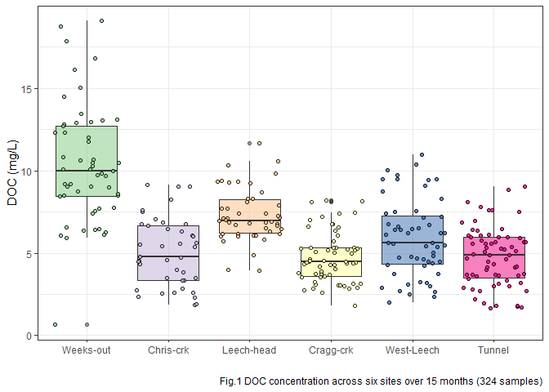

Table 1: summary of DOC concentrations at the six main sites

|  |  |  |  |
| --- | --- | --- | --- |
| **Table 1: mean DOC** | | | |
| **site** | **mean DOC**  **(mg/L)** | **std.dev.**  **(± mg/L)** | **RSD**  **(%)** |
| **Weeks-out** | 10.4 | 3.6 | 34.4 |
| **Chris-crk** | 5.1 | 2.1 | 40.9 |
| **Leech-head** | 7.3 | 1.6 | 22.1 |
| **Cragg-crk** | 4.7 | 1.5 | 32.4 |
| **West-Leech** | 5.9 | 2.3 | 39.2 |
| **Tunnel** | 4.8 | 1.8 | 37.7 |

At the six subbasin monitoring sites, vertical racks were installed to collect samples as the rivers rose in response to precipitation events.

These vertical racks collected samples on the rising hydrograph limb, which has been shown to have higher DOC concentration that non-storm flow (Yang et al. 2015; Raymond et al. 2016, 2010). As the vertical racks require a hydrologic response to collect samples, they are only applicable during the wet season. Comparing wet season Grab samples to those collected on Racks confirms that the rack samplers were able to capture more samples, and many during periods with higher DOC concentrations (Fig.2).

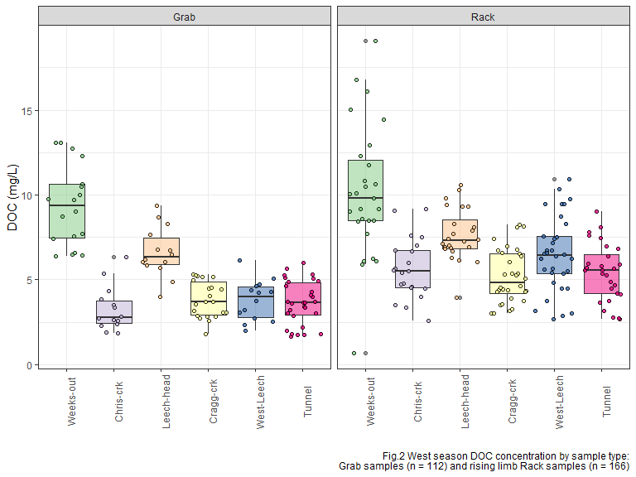

## Sampling campaign

Four hundred water sample were collected and analyzed for DOC over a 16 month study period (October 2018 to February 2020). The synoptic grab-sampling program was enhanced by the collection of stormflow on the six vertical sampling racks. In total, 171 samples were collected on vertical Racks, 215 Grab samples were collected at 15 synoptically sampled sites (which included the six installation sites), and an additional 14 Grab samples were collected opportunistically at one-off sites across the water supply area. Figure 3 shows DOC concentrations across the 15 synoptically sampled sites over the study period (n=386).

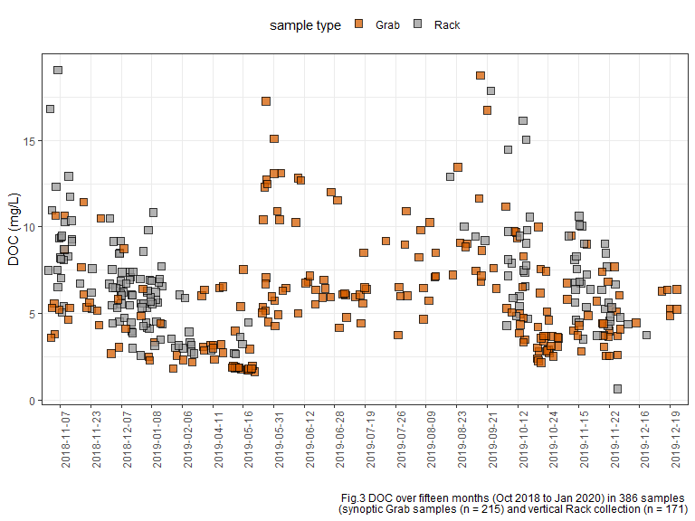 Over the study period, DOC concentrations decreased throughout the wet season, and increased again during the dry summer months (Fig.3). This seasonal DOC concentration pattern was clear at each of the six installation locations in the LWSA (Fig.4).

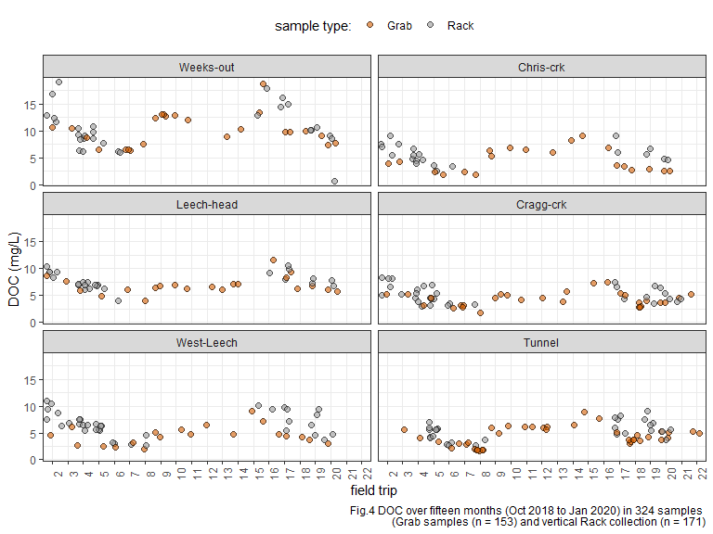

## Seasonal examination of DOC & DOM dynamics

In this section, a categorical season ID was used to assess temporal variations in DOC. Seasons were separated based on months of the year: the wet season was October through May, and the dry season was June until October.

* Precipitation data will be employed to operationally separate season (data obtained January 31, 2020 from CRD).

These seasonal plots show data from both Rack and Grab samples in order to include the full available range of concentrations.

In the wet season, DOC concentrations generally increased during stormflow (relative to between-storm peaks) *{data not shown here}*, and progressively dropped over the course of the wet season. During dry season baseflow, DOC concentration was elevated compared to late wet season DOC (Fig.5).

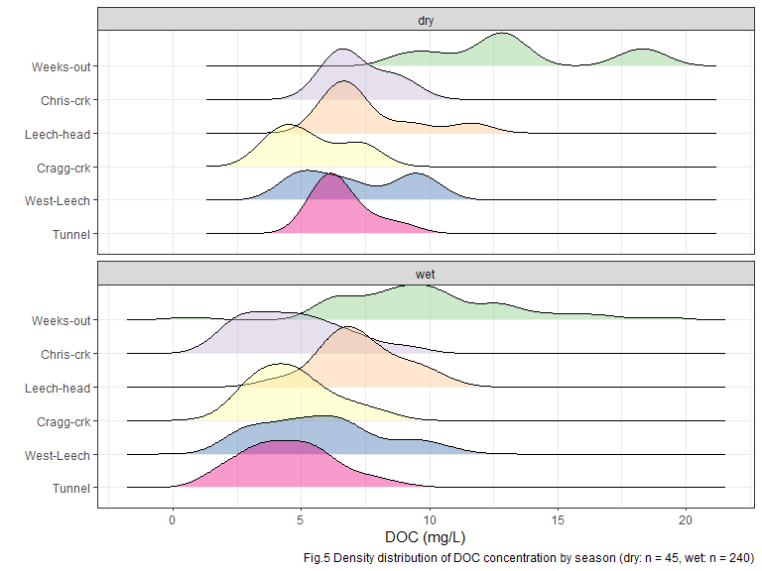

At each of the six sub-basin monitoring locations, mean DOC was higher during the dry season than during the wet season (Table 2, Fig.8). There was less variation in dry season DOC concentrations at each site also (Table 2), which could be due to actual reduction in variance in the absence of stormflow pulses and also due to fewer dry season samples (n = 46) compared to wet season samples (n = 278).

|  |  |  |  |  |
| --- | --- | --- | --- | --- |
| **Table 2: seasonal DOC, Rack and Grab (n=324)** | | | | |
| **season** | **site** | **mean DOC (mg/L)** | **std.dev. (± mg/L)** | **RSD (%)** |
| Weeks-out | dry | 13.4 | 3.4 | 25.3 |
| Weeks-out | wet | 9.8 | 3.4 | 34.2 |
| Chris-crk | dry | 7.2 | 1.2 | 16.0 |
| Chris-crk | wet | 4.7 | 2.0 | 42.0 |
| Leech-head | dry | 7.6 | 1.9 | 25.3 |
| Leech-head | wet | 7.3 | 1.6 | 21.6 |
| Cragg-crk | dry | 5.4 | 1.5 | 27.2 |
| Cragg-crk | wet | 4.7 | 1.5 | 33.0 |
| West-Leech | dry | 7.1 | 2.1 | 29.9 |
| West-Leech | wet | 5.7 | 2.3 | 40.4 |
| Tunnel | dry | 6.6 | 1.0 | 15.6 |
| Tunnel | wet | 4.5 | 1.7 | 38.7 |

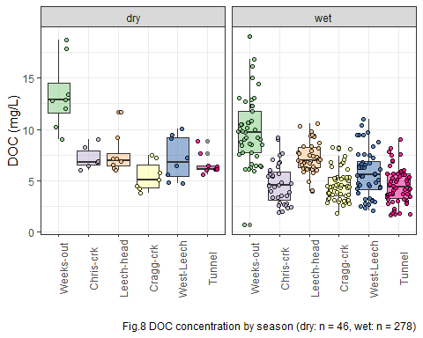

To remove the variance of stormflow DOC concentrations, Table 2-B and Figure 9 shows seasonal concentrations based only on Grab samples (excludes 166 stormflow samples collected by Racks).

|  |  |  |  |  |
| --- | --- | --- | --- | --- |
| **season** | **site** | **mean DOC (mg/L)** | **std.dev. (± mg/L)** | **RSD (%)** |
| Weeks-out | dry | 12.7 | 3.4 | 26.6 |
| Weeks-out | wet | 9.3 | 2.4 | 25.4 |
| Chris-crk | dry | 7.2 | 1.2 | 16.0 |
| Chris-crk | wet | 3.3 | 1.3 | 39.9 |
| Leech-head | dry | 7.3 | 1.9 | 26.5 |
| Leech-head | wet | 6.6 | 1.5 | 22.2 |
| Cragg-crk | dry | 5.4 | 1.5 | 27.2 |
| Cragg-crk | wet | 3.8 | 1.1 | 27.8 |
| West-Leech | dry | 6.3 | 1.7 | 26.6 |
| West-Leech | wet | 3.8 | 1.2 | 31.5 |
| Tunnel | dry | 6.6 | 1.0 | 15.6 |
| Tunnel | wet | 3.6 | 1.3 | 35.6 |

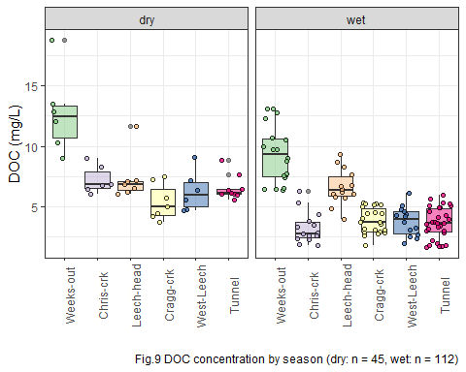

## DOC and metals in solution

Aquatic NOM can play an important role in the transport of metals because it has the physiochemical ability to act as a ligand to create coordinated complexes with metals. From November 2018 to July 2019, I collected eight sets of samples for metals analysis from the six sub-basin monitoring sites. Metals samples were collected on behalf of the CRD and were analyzed at Bureau Veritas Laboratories in Sidney, BC (formerly Maxxam Analytics Inc.). For each metals sample collected, a parallel Grab sample was analyzed for DOC. There was a suite of metals included in the analyses, many of which were below detection limits; Figure XXXXX shows DOC concentrations from samples which had detectable concentrations of eight metal species.

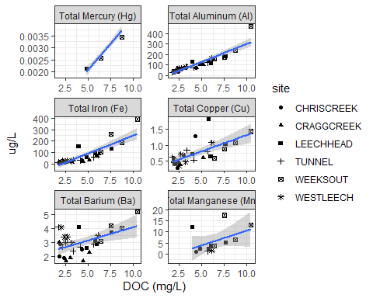

DOC concentration had a strong positive relationship with total mercury (R2=0.9998, n=3) aluminum (R2=0.81, n=36), and iron (R2=0.72, n=36). While the relationships were not as strong, DOC was also positively related to concentrations of copper (R2=0.47, n=27), barium (R2=0.25, n=30), and manganese (R2=0.21, n=12). Not included in FIGUREYYYYYY is the weak inverse relationship between DOC and silicon (R2=0.061, n=29) and magnesium (R2=0.015, n=30). All metals concentrations were below maximum allowable concentrations and aesthetic objectives for source water guidelines (**???**).

## Sampling campaign

Four hundred water sample were collected and analyzed for DOC over a 16 month study period (October 2018 to February 2020). The synoptic grab-sampling program was enhanced by the collection of stormflow on the six vertical sampling racks. In total, 171 samples were collected on vertical Racks, 215 Grab samples were collected at 15 synoptically sampled sites (which included the six installation sites), and an additional 14 Grab samples were collected opportunistically at one-off sites across the water supply area. Figure 3 shows DOC concentrations across the 15 synoptically sampled sites over the study period (n=386).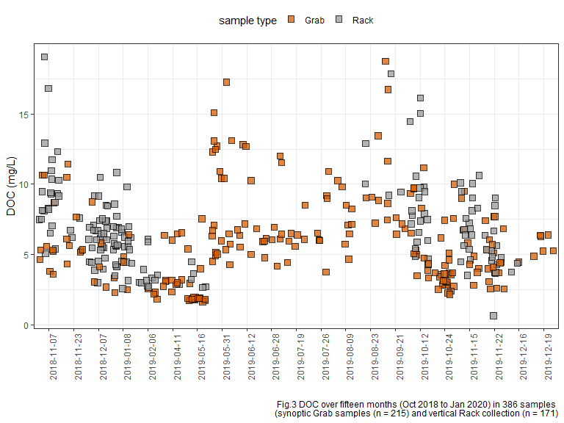

Over the study period, DOC concentrations decreased throughout the wet season, and increased again during the dry summer months (Fig.3). This seasonal DOC concentration pattern was clear at each of the six installation locations in the LWSA (Fig.4).

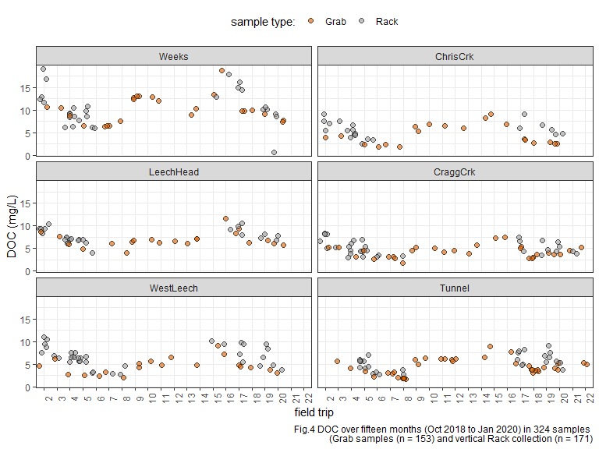

## Seasonal examination of DOC & DOM dynamics

In this section, a categorical season ID was used to assess temporal variations in DOC. Seasons were separated based on months of the year: the wet season was October through May, and the dry season was June until October.

* Precipitation data will be employed to operationally separate season (data obtained January 31, 2020 from CRD).

These seasonal plots show data from both Rack and Grab samples in order to include the full available range of concentrations.

In the wet season, DOC concentrations generally increased during stormflow (relative to between-storm peaks) *{data not shown yet}*, and progressively dropped over the course of the wet season. During dry season baseflow, DOC concentration was elevated compared to late wet season DOC (Fig.5).

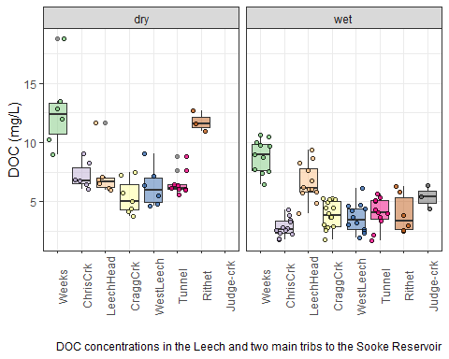

### Plots of DOC & proxy

DOC was quantified as non-purgeable organic carbon (NPOC) on the Shimadzu TOC auto analyzer, and samples were also measured on a Spectrolyser spectrophotometer. A spectrophotometer can only measure the fraction of organic matter that is able to absorb UV or Visible light, and therefore DOC measured on the Spectrolyser was a measure of CDOM and an indicator of aromaticity (molecular character).

Figure 6 shows results from all samples comparing DOC concentrations (as NPOC, direct measure) to CDOM concentrations (UV-Vis, proxy measure of DOC). There was a strong seasonal separation of the relationship between these two measurements. These results indicate a seasonally-driven physiochemical difference in the aquatic NOM in this drinking water supply area. 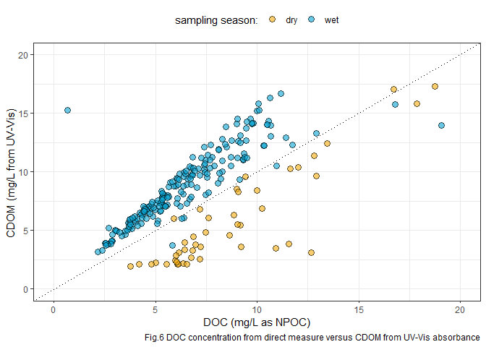

Figure 7 shows the same DOC-CDOM comparison from Figure 6, isolated to the six sub-basin monitoring sites. The seasonal relationship appears similar for the six sites.

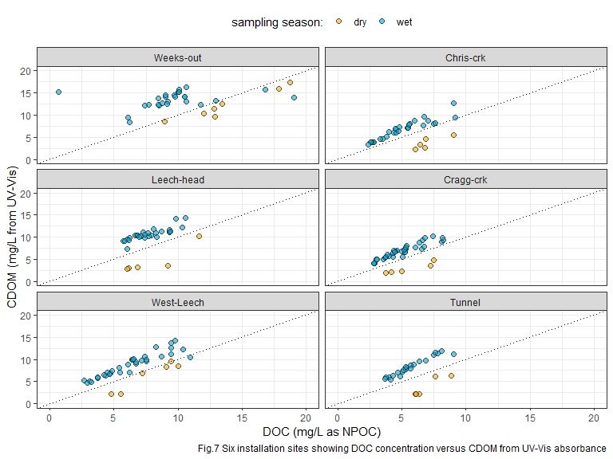

At each of the six sub-basin monitoring locations, mean DOC was higher during the dry season than during the wet season (Table 2, Fig.8). There was less variation in dry season DOC concentrations at each site also (Table 2), which could be due to actual reduction in variance in the absence of stormflow pulses and also due to fewer dry season samples (n = 46) compared to wet season samples (n = 278).

## Spectral Indices

…in progress: plotting of spectral fingerprint data for slope ratio indices, which will help to elucidate seasonal DOM character shifts.

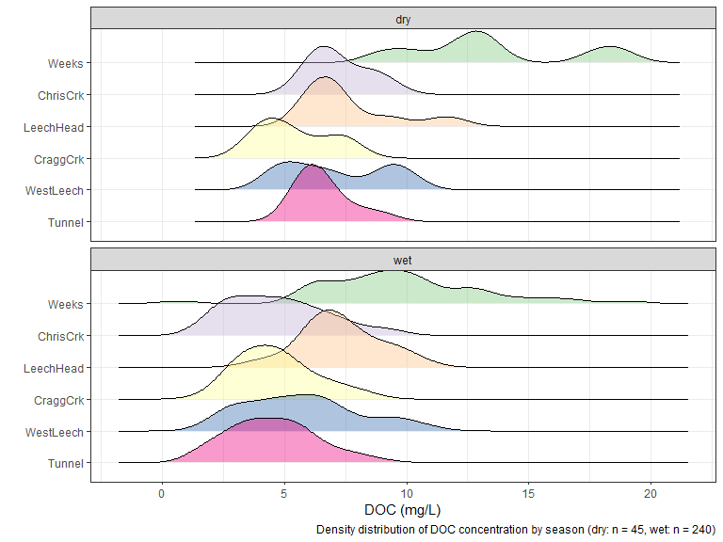

# Discussion

…in progress…

# Conclusions

I did several things and will now summarize why they are good.

# References

Abbott, Benjamin W., Gérard Gruau, Jay P. Zarnetske, Florentina Moatar, Lou Barbe, Zahra Thomas, Ophélie Fovet, et al. 2018. “Unexpected spatial stability of water chemistry in headwater stream networks.” *Ecology Letters* 21 (2): 296–308. <https://doi.org/10.1111/ele.12897>.

Aiken, George R., Heileen Hsu-Kim, and Joseph N. Ryan. 2011. “Influence of dissolved organic matter on the environmental fate of metals, nanoparticles, and colloids.” *Environmental Science and Technology* 45 (8): 3196–3201. <https://doi.org/10.1021/es103992s>.

Avagyan, Armine, Benjamin R. K. Runkle, and Lars Kutzbach. 2014. “Application of high-resolution spectral absorbance measurements to determine dissolved organic carbon concentration in remote areas.” *Journal of Hydrology* 517: 435–46. <https://doi.org/10.1016/j.jhydrol.2014.05.060>.

British Columbia Ministry of Environment. 2017. “Source Drinking Water Quality Guidelines: Guideline Summary.” Victoria, B.C.: Prov. B.C. <https://www2.gov.bc.ca/gov/content/governments/organizational-structure/ministries-organizations/ministries/environment-climate-change>.

Chow, Alex T., Randy A. Dahlgren, Qian Zhang, and P. K. Wong. 2008. “Relationships between specific ultraviolet absorbance and trihalomethane precursors of different carbon sources.” *Journal of Water Supply: Research and Technology - AQUA* 57 (7): 471–80. <https://doi.org/10.2166/aqua.2008.064>.

CRD. 2017. “Regional Water Supply 2017 Strategic Plan.” Victoria, B.C.: Capital Region District, Integrated Water Services. <https://www.crd.bc.ca/project/past-capital-projects-and-initiatives/water-supply-plan>.

———. 2019. “Leech Water Supply Area Restoration Update: Report to Regional Water Supply Commission (Wednesday, June 19, 2019).” Victoria, B.C.: Capital Regional District. <https://doi.org/IWSS-297445977-5079>.

Creed, IF Irena F, DM Diane M Mcknight, Brian A Pellerin, Mark B Green, Brian A Bergamaschi, George R Aiken, Douglas A Burns, et al. 2015. “The river as a chemostat : fresh perspectives on dissolved organic matter flowing down the river continuum.” *Canadian Journal of Fisheries and Aquatic Sciences* 14 (April): 1–14. <https://doi.org/10.1139/cjfas-2014-0400>.

Delpla, Ianis, and Manuel J. Rodriguez. 2016. “Experimental disinfection by-product formation potential following rainfall events.” *Water Research* 104: 340–48. <https://doi.org/10.1016/j.watres.2016.08.031>.

Dudley, N, and S Stolton. 2003. “Running Pure: The importance of forest protected areas to drinking water.” World Bank / WWF Alliance for Forest Conservation; Sustainable Use. [http://scholar.google.com/scholar?hl=en{\&}btnG=Search{\&}q=intitle:Running+Pure{\#}1](http://scholar.google.com/scholar?hl=en%7B\&%7DbtnG=Search%7B\&%7Dq=intitle:Running+Pure%7B\#%7D1).

Eaton, A. D., Clesceri, L. S., Greenberg, A. E., Franson, M. A. H. 2000. “Total Organic Carbon (TOC) - 5310 A.” In *Standard Methods for the Examination of Water and Wastewater*, 6th ed., 19–20. Washington, DC: American Public Health Association. <http://www.standardmethods.org/>.

Graczyk, David J., Dale M. Robertson, William J. Rose, and Jeffrey J. Steur. 2000. “Comparison of water-quality samples collected by siphon samplers and automatic samplers in Wisconsin.” Middleton, Dane County, Wisconsin: U.S. Department of the Interior U.S. Geological Survey. <https://doi.org/10.3133/fs06700>.

Health Canada. 2019. “Guidance on Natural Organic Matter in Drinking Water.” <https://www.canada.ca/content/dam/hc-sc/documents/programs/consultation-organic-matter-drinking-water/NOM20190129-eng.pdf>.

HealthCanada. 2006. “Drinking Water Chlorination.” <https://www.canada.ca/en/health-canada/services/healthy-living/your-health/environment/drinking-water-chlorination.html>.

HealthLinkBC. 2018. “Drinking Water Chlorination Facts.” <https://www.healthlinkbc.ca/healthlinkbc-files/drinking-water-chlorination>.

Helms, John R, Avon Stubbins, Jason D Ritchie, Elizabeth C Minor, and Kenneth Mopper. 2008. “Absorption Spectral Slopes and Slope Ratios as Indicators of Molecular Weight , Source , and Photobleaching of Chromophoric Dissolved Organic Matter Author ( s ): John R . Helms , Aron Stubbins , Jason D . Ritchie , Elizabeth C . Minor , David J . Kieber.” *Limnology and Oceanography* 53 (3): 955–69. <https://www.jstor.org/stable/40058211>.

Hua, Guanghui, David A. Reckhow, and Ibrahim Abusallout. 2015. “Correlation between SUVA and DBP formation during chlorination and chloramination of NOM fractions from different sources.” *Chemosphere* 130: 82–89. <https://doi.org/10.1016/j.chemosphere.2015.03.039>.

Johnson, Lucinda, Carl Richards, George Host, and John Arthur. 1997. “Landscape influences on water chemistry in Midwestern stream ecosystems.” *Freshwater Biology* 37: 193–208. <https://doi.org/doi:10.1046/j.1365-2427.1997.d01-539.x>.

LaZerte, Bruce. 1991. “Metal transport and retention: the role of dissolved organic carbon.” December. Ontario: Dorset Research Centre, for Ontario Ministry of the Environment. <https://archive.org/details/metaltransportre00lazeuoft/mode/2up>.

Li, Angzhen, Xu Zhao, Ran Mao, Huijuan Liu, and Jiuhui Qu. 2014. “Characterization of dissolved organic matter from surface waters with low to high dissolved organic carbon and the related disinfection byproduct formation potential.” *Journal of Hazardous Materials* 271: 228–35. <https://doi.org/10.1016/j.jhazmat.2014.02.009>.

Matilainen, Anu, Egil T. Gjessing, Tanja Lahtinen, Leif Hed, Amit Bhatnagar, and Mika Sillanpää. 2011. “An overview of the methods used in the characterisation of natural organic matter (NOM) in relation to drinking water treatment.” *Chemosphere* 83 (11): 1431–42. <https://doi.org/10.1016/j.chemosphere.2011.01.018>.

Meyer, Judy L., and Cathy M . Tate. 1983. “The Effects of Watershed Disturbance on Dissolved Organic Carbon Dynamics of a Stream Author.” *Ecology* 64 (1): 33–44. <https://www.jstor.org/stable/1937326>.

Mistick, Emily. 2019. “FOREST HARVEST AND WATER TREATABILITY: ANALYSIS OF DISSOLVED ORGANIC CARBON IN HEADWATER STREAMS OF CONTRASTING FOREST HARVEST HISTORY DURING BASE FLOW AND STORM FLOW.” PhD thesis, UNIVERSITY OF BRITISH COLUMBIA.

Mosher, Jennifer J., Louis A. Kaplan, David C. Podgorski, Amy M. McKenna, and Alan G. Marshall. 2015. “Longitudinal shifts in dissolved organic matter chemogeography and chemodiversity within headwater streams: a river continuum reprise.” *Biogeochemistry* 124 (1-3): 371–85. <https://doi.org/10.1007/s10533-015-0103-6>.

Oni, S. K., M. N. Futter, K. Bishop, S. J. Köhler, M. Ottosson-Löfvenius, and H. Laudon. 2013. “Long-term patterns in dissolved organic carbon, major elements and trace metals in boreal headwater catchments: Trends, mechanisms and heterogeneity.” *Biogeosciences* 10 (4): 2315–30. <https://doi.org/10.5194/bg-10-2315-2013>.

Palleiro, L., M. L. Rodríguez-Blanco, M. M. Taboada-Castro, and M. T. Taboada-Castro. 2013. “The influence of discharge, pH, dissolved organic carbon, and suspended solids on the variability of concentration and partitioning of metals in a rural catchment.” *Water, Air, and Soil Pollution* 224 (8). <https://doi.org/10.1007/s11270-013-1651-9>.

Pike, R., M. Feller, J. Stednick, K Rieberger, and M Carver. 2010. “Water Quality and Forest Management.” In *Compendium of Forest Hydrology and Geomorphology in British Columbia: Volume 2 of 2*, 400–439. [https://www.for.gov.bc.ca/hfd/pubs/docs/lmh/Lmh66/LMH66{\_}volume2of2.pdf](https://www.for.gov.bc.ca/hfd/pubs/docs/lmh/Lmh66/LMH66%7B_%7Dvolume2of2.pdf).

Rautu, Roxana. 2019. “Linking Seasonal and Spatial Stream Carbon Dynamics to Landscape Characteristics in Selected Watersheds on the Olympic Peninsula.” PhD thesis, University of Washington.

Raymond, Peter A, James E Saiers, Source Biogeochemistry, No September, Peter A Raymond, and James E Saiers. 2010. “Event controlled DOC export from forested watersheds.” *Biogeochemistry* 100 (1): 197–209. <https://doi.org/10.1007/sl0533-010-9416-7>.

Raymond, Peter A, James E Saiers, William V Sobczak, and E James. 2016. “Hydrological and biogeochemical controls on watershed dissolved organic matter transport: pulse-shunt concept.” *Ecology* 97 (1): 5–16. <https://www.jstor.org/stable/24702986>.

Richardson, Susan D., Michael J. Plewa, Elizabeth D. Wagner, Rita Schoeny, and David M. DeMarini. 2007. “Occurrence, genotoxicity, and carcinogenicity of regulated and emerging disinfection by-products in drinking water: A review and roadmap for research.” *Mutation Research - Reviews in Mutation Research* 636 (1-3): 178–242. <https://doi.org/10.1016/j.mrrev.2007.09.001>.

Stanley, Emily H., Stephen M. Powers, Noah R. Lottig, Ishi Buffam, and John T. Crawford. 2012. “Contemporary changes in dissolved organic carbon (DOC) in human-dominated rivers: Is there a role for DOC management?” *Freshwater Biology* 57 (SUPPL. 1): 26–42. <https://doi.org/10.1111/j.1365-2427.2011.02613.x>.

Ussery, Joel, and AECOM. 2015. “Leech Water Supply Area: An Assessment for Source Water Protection and Land Management.” April. Victoria, B.C.: Capital Regional District, Watershed Protection Division, Integrated Water Services.

Vannote, Robin L., G. Wayne Minshall, Kenneth W. Cummins, James R. Sedell, and Colbert E. Cushing. 1980. “The River Continuum Concept.” *Canadian Journal of Fisheries and Aquatic Sciences* 30 (1): 130–37.

Vidon, Philippe, Laura E. Wagner, and Emmanuel Soyeux. 2008. “Changes in the character of DOC in streams during storms in two Midwestern watersheds with contrasting land uses.” *Biogeochemistry* 88 (3): 257–70. <https://doi.org/10.1007/s10533-008-9207-6>.

Weishaar, James L., George R. Aiken, Brian A. Bergamaschi, Miranda S. Fram, Roger Fujii, and Kenneth Mopper. 2003. “Evaluation of specific ultraviolet absorbance as an indicator of the chemical composition and reactivity of dissolved organic carbon.” *Environmental Science and Technology* 37 (20): 4702–8. <https://doi.org/10.1021/es030360x>.

Yang, Liyang, Jin Hur, Sonmin Lee, Soon Woong Chang, and Hyun Sang Shin. 2015. “Dynamics of dissolved organic matter during four storm events in two forest streams: source, export, and implications for harmful disinfection byproduct formation.” *Environmental Science and Pollution Research* 22 (12): 9173–83. <https://doi.org/10.1007/s11356-015-4078-6>.

Zarnetske, Jay P., Martin Bouda, Benjamin W. Abbott, James Saiers, and Peter A. Raymond. 2018. “Generality of Hydrologic Transport Limitation of Watershed Organic Carbon Flux Across Ecoregions of the United States.” *Geophysical Research Letters* 45 (21): 11, 702–11, 711. <https://doi.org/10.1029/2018GL080005>